AI Assisted Coding

ASSIGNMENT 1.2
Name: PRUDVI RAJ. K
H.TNO: 2303A52349
BATCH = 32
Question 1:
Task 1:
AI-Generated Logic Without Modularisation (Factorial without
Functions)

Scenario: You are building a small command-line utility for a startup intern onboarding task. The program is simple and must be written quickly without a modular design.

Task Description: Use GitHub Copilot to generate a Python program that computes a mathematical product-based value (factorial-like logic) directly in the main execution flow, without using any user-defined functions.

• Constraint:
Do not define any custom function
Logic must be implemented using loops and variables only

Prompt:
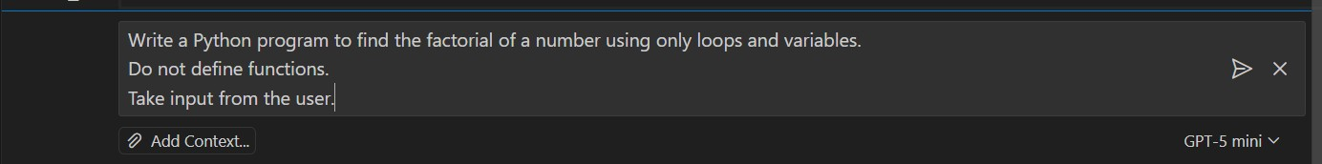
Code Screenshot:
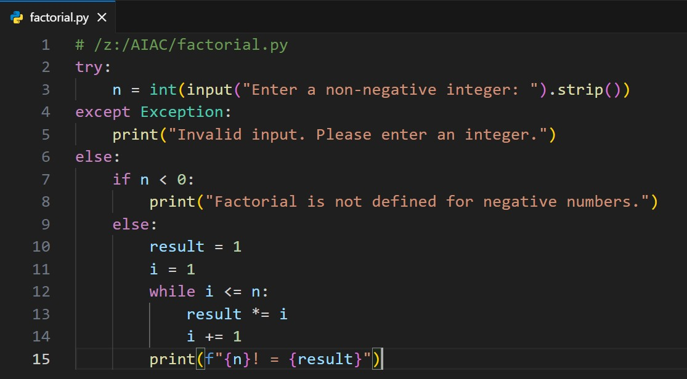
Output(O/P):
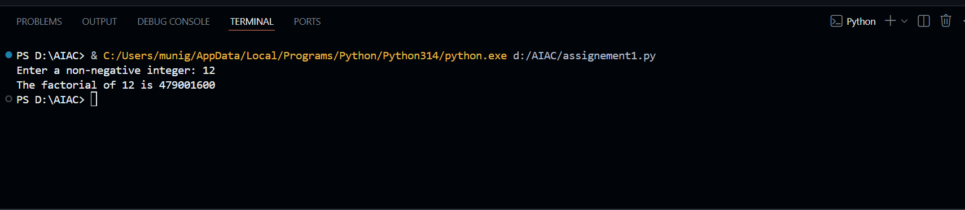
Copilot Suggestions:
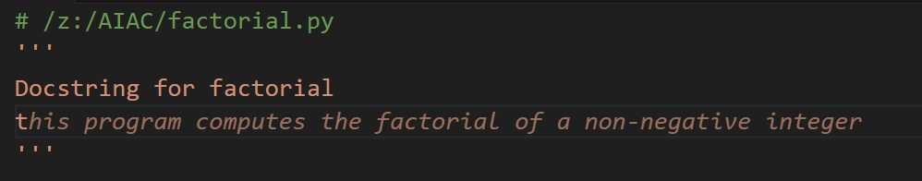

Explanation:
Copilot was very helpful for a beginner as it quickly generated correct logic based on the prompt. It reduced the time required to write the code by suggesting a complete solution.
The generated code followed best practices such as input validation and edge case handling. Copilot also helped in avoiding syntax errors and logical mistakes.
Overall, it made coding easier & faster.

Question 2:
Scenario: Your team lead asks you to review AI-generated code before committing it to a shared repository.
Task Description: Analyse the code generated in Task 1 and use Copilot again to:
Reduce unnecessary variables
Improve loop clarity
Enhance readability and efficiency
Hint: Prompt Copilot with phrases like
“optimise this code”,
“simplify logic”, or
“Make it more readable”

Prompt:
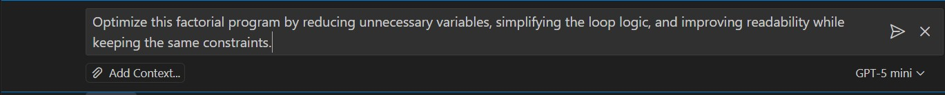
Code Screenshot:
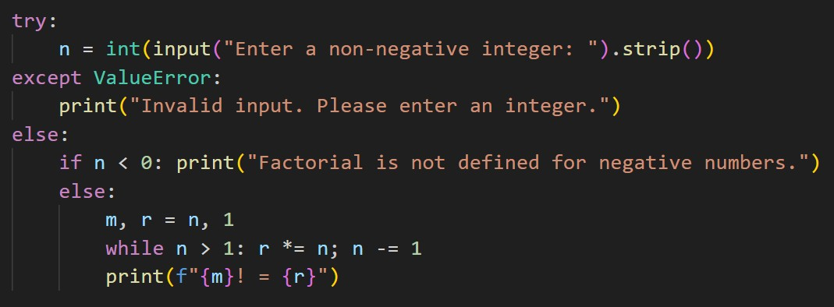
Output(O/P):
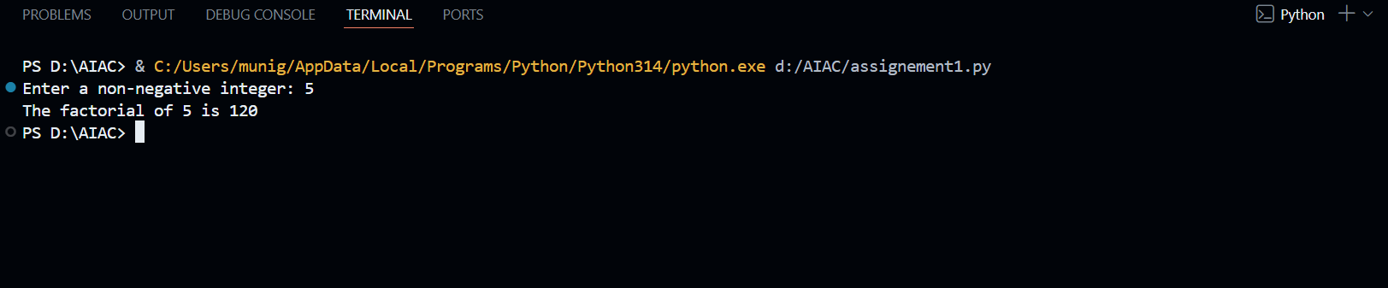
Explanation:
Optimized the code in minimal number of lines and short variable names

Question 3:
Scenario: The same logic now needs to be reused in multiple scripts.
Task Description Use GitHub Copilot to generate a modular version of the program by:
Creating a user-defined function Calling the function from the main block Constraints:
Use meaningful function and variable names
Include inline comments (preferably suggested by Copilot) Prompt:
Code Screenshot:
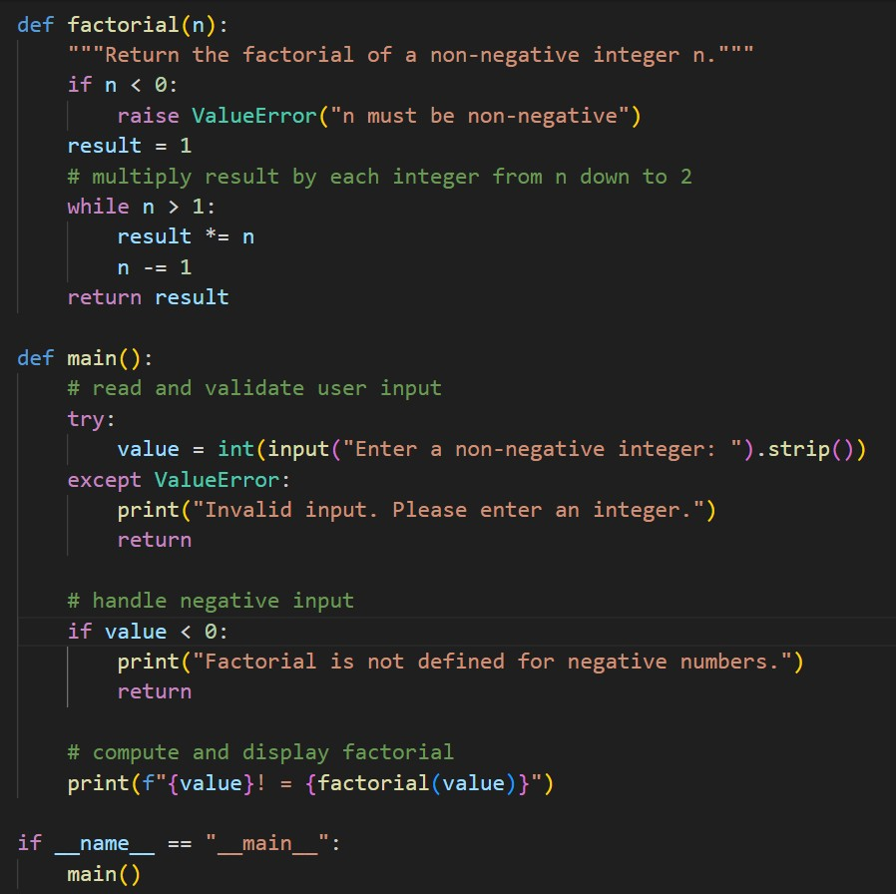

Output(O/P):
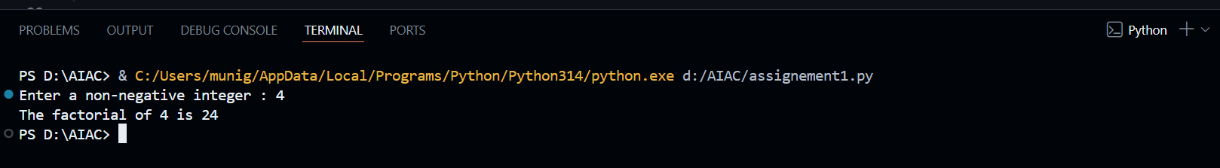

Explanation:
Copilot Modified The Code To Function Type
& main block is created
Handled Edge Cases Well

Question 4:
Scenario As part of a code review meeting, you are asked to justify design choices.
Task Description Compare the non-function and function-based Copilot-generated programs on the following criteria:
Logic clarity
Reusability
Debugging ease
Suitability for large projects AI dependency risk
Explanation:

Aspect | Non-function based | Function-based
Logic clarity | Logic is in one block.  Harder to understand | Logic is separated.  Easy to understand
Reusability | Code cannot be reused | Code can be reused easily
Debugging ease | Debugging is difficult | Debugging is easy
Suitability for large projects | Not suitable for large projects | Suitable for large projects
AI dependency risk | High risk of blind copying | Lower risk due to clear structure

Question 5:
Scenario:
Your mentor wants to test how well AI understands different computational paradigms.
Task Description:
Prompt Copilot to generate:
An iterative version of the logic A recursive version of the same logic Constraints: Both implementations must produce identical outputs Students must not manually write the code first

Prompt 1:
Code:
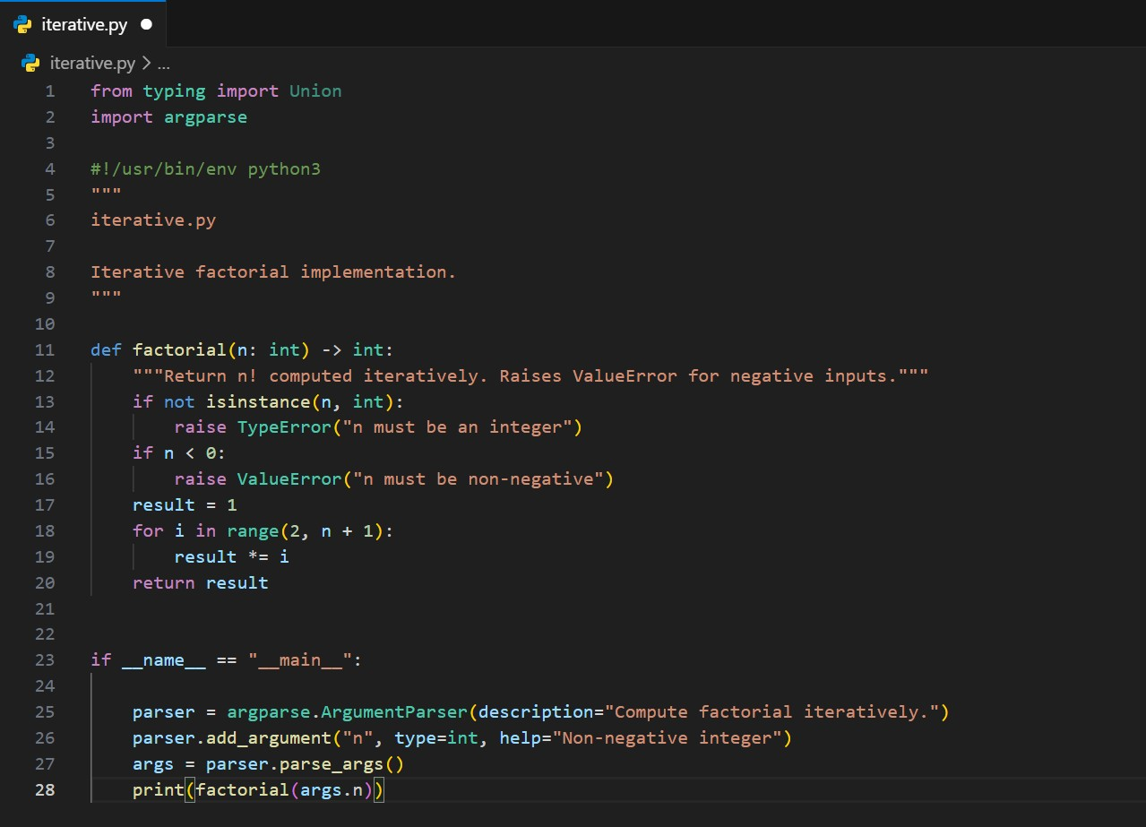

Output:

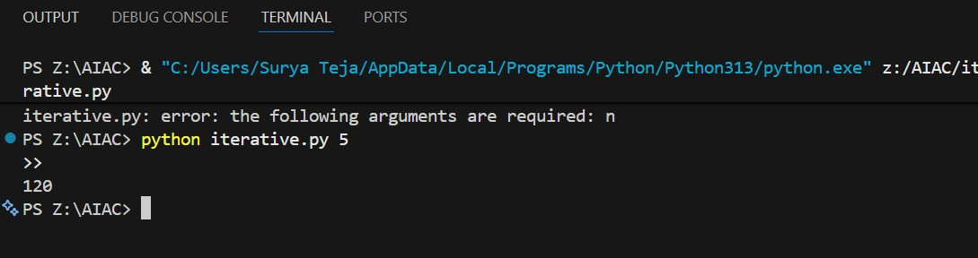
Prompt 2:
Code:
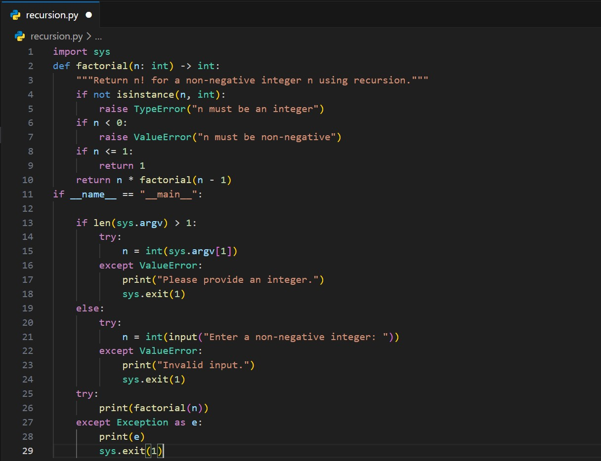
Output:
Iterative version:
The program starts with an initial value and repeatedly updates it using a loop until the condition is satisfied. The control flow stays within a single function and finishes once the loop ends.
Recursive version:
The program calls itself with a smaller input each time. Each call waits on the stack until the base condition is reached. After that, results are returned step by step.
Aspect | Iterative | Recursive
Readability | Easy to follow for beginners | Slightly harder due to function calls
Stack usage | Uses constant memory | Uses call stack for each function call
Performance implications | Faster and memory  efficient | Slower for large inputs due to stack overhead
When recursion is not recommended | Always safe for large inputs | Not recommended when input  size is large or stack overflow is possible

